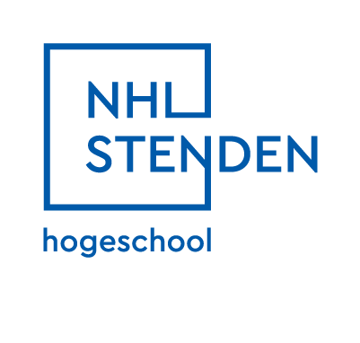
Reflection Report
on the First Semester of IT Studies

Student: Corodeanu David Cristian
Studentnumber: 5448980
Study Career Coach: Lionel Smith
Date: 1/16/2026

The purpose of this report is to reflect on my first semester in year 2 of studies at NHL Stenden and evaluate its impact on my studies and life. In this report, I talk about my experiences with project work, teamwork, time pressure, and how these influenced both my studies and personal life. Following the previous reports in which I talked about my experiences in the first year of university, I continue this series by reflecting on my second year of studies and my life in the Netherlands.
The first semester started directly with the project kick-off on the first day, along with a lot of new information and tasks to complete. It started out fun, with all the clients presenting their projects, but it became very stressful very quickly because we were put on the spot to choose a project without any time to think further or research what each project was really about. Luckily, together with some friends, we decided quickly to choose the same top three projects, and most of us ended up in the same group, so at least I could work together with people I already knew. We also had to create a Personal Development Plan and choose three goals that we wanted to achieve by the end of the semester. My three goals were as follows: learning more Dutch by watching the news every week, broadening my culinary expertise by learning how to make ten new recipes, and getting a job and working at least eight hours a week in order to receive my DUO allowance. After that, a few weeks of documentation followed, during which we became more familiar with the project, and we started learning how to use JIRA for task and time management. Working with JIRA helped me better understand structured task planning and time management within a team environment, which I think is very important. In the third week, we had a trip to Utrecht for an internship fair, which was very enjoyable, and I also got to see more of that beautiful city. A few days later, I had another major event, which was the MDT presentations for the project I completed together with my team last university year. There were around ten teams with different subjects related to storytelling and helping minorities, and my team and I worked on a project focused on helping deaf people be heard by the community and share their stories. The rest of the period was relatively quiet after that, except for the final week, when we had to finish and complete everything for the project. In the end, everything went very well, and the client and teachers were pleased with what we delivered and gave us positive feedback, which made me feel relieved and happy.
During the exam week, I took a small trip to Spain with the help of the RUN-EU programme and had a lot of fun visiting and discovering the amazing culture and architecture of the city of Burgos. However, it was also one of the busiest weeks of my life, as I woke up at 7 a.m. every day and was outside until 9–10 p.m., walking over 25–30 thousand steps per day.
Right after that, the second period began without even a short break to rest. During both weekends before and after the week in Spain, I was either travelling or working at my part-time job at KFC, so I was exhausted and in need of a vacation, but I still had to push through and start working on a new project. Luckily, it was not completely new, as we were allowed to continue the project we had already started, although it expanded greatly in terms of requirements. Even more so, in the third week, we found out that the client had spoken with someone else and promised that our project would be used at a hackathon-style event next year. As a result, we suddenly had to create a fully working application, whereas before it was only meant to be a prototype. This sudden change taught me how quickly project requirements can evolve and how important flexibility and communication are in real-world projects. Many hard and demanding weeks followed, during which we worked constantly with little time to rest or do something for ourselves. However, I was able to recover somewhat during the Christmas vacation, when I returned to Romania to visit my parents, which helped, even though it was still tiring.
Now it is the last day, and together with my team, I have managed to make everything work. We are ready to hand in all the required documents and finally rest for a few days before the exam week. Looking back, I realize that I should have planned my time more carefully and protected moments for rest, as constant pressure affected my energy and focus. I am very happy and relieved that I managed to accomplish all the goals I set for myself in my Personal Development Plan. As a result, I am now fully independent and earn enough money to pay for my rent and food, which I am also able to cook myself. Working alongside my studies also helped me practice the Dutch I learned from watching the news and attending university lessons. Additionally, I gave feedback to everyone I worked with and have received in response very positive feedback from my colleagues shortly before writing this report, and I will take this feedback with me into the upcoming semester in order to continue improving myself, especially in terms of delegating tasks better and allowing myself more time to rest.
All things considered, I learned a great deal during the past half year, and it will certainly help me in the future. Despite the challenges, this semester helped me grow both academically and personally and prepared me better for future projects with higher expectations. I just wish I had more time to rest, but summer will eventually come.

